Azure Application Monitoring Strategy

Centralized Monitoring, Observability, Alerting & Troubleshooting

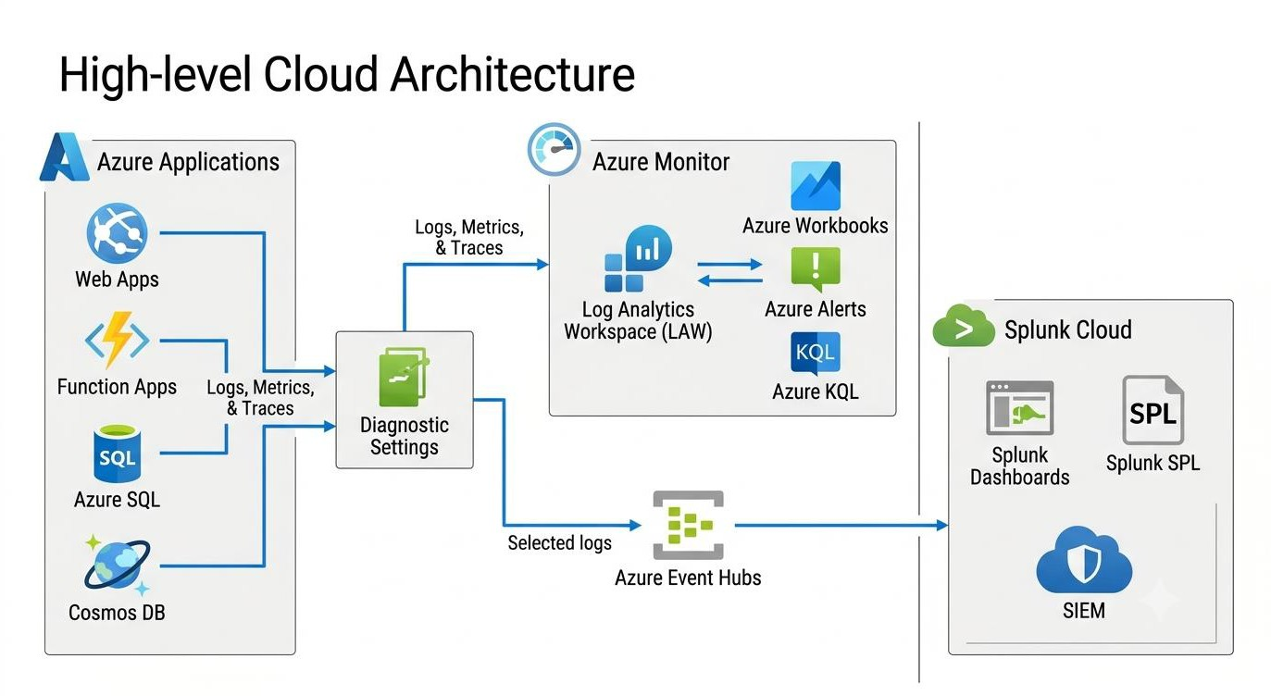

Why do we need monitoring?

Imagine we have an application hosted in Azure. Users suddenly report that the application is slow or
unavailable.
Without proper monitoring, the support team has to:
- Check whether the application is running.
- Connect to different Azure resources.
- Check application logs manually.
- Ask infrastructure teams whether CPU, memory or network usage is normal.
- Search for errors across multiple systems.
- Try to identify when and where the problem started.
This takes time, and sometimes the issue gets resolved before the actual root cause is identified. With proper monitoring, we can have a centralized view of application health, infrastructure performance, errors, dependencies and availability.

Monitoring, logs, metrics, traces and observability

Metrics – What is happening?
Numerical measurements collected over time.
Examples: CPU 85%, memory 90%, request count, response time, HTTP 5xx count.
Logs – What happened?
Detailed records of events and activities.
Examples: Application exceptions, authentication failures, deployment events and database errors.
Traces – Where did the request go?
Follow a request across multiple application components.
Examples: API Gateway → App Service → Database → External API.
Observability – Why did it happen?
Combining metrics, logs and traces to understand system behaviour.
Example: Identify why an API became slow and which dependency caused the delay.

Azure monitoring services: What do we actually need?

Azure resource | Important metrics | Logs / telemetry to monitor
Azure Web Apps | CPU, memory, HTTP 4xx/5xx, response time, requests | HTTP logs, application logs, console logs, exceptions
Azure Function Apps | Function executions, failures, duration, memory | Function execution logs, exceptions, host logs, dependencies
Azure SQL Database | DTU/vCore, CPU, storage, connections, deadlocks | Auditing, errors, query performance, timeouts
Azure PostgreSQL | CPU, memory, connections, storage, IOPS | PostgreSQL logs, connection failures, slow queries, deadlocks
Azure Cosmos DB | RU consumption, throttling, latency, availability | Data-plane requests, 429 errors, diagnostic resource logs
Storage Account (Blob) | Availability, latency, capacity, transactions | Read/write/delete operations, authentication failures
Application Gateway + WAF | Throughput, backend health, latency, failed requests | Access logs, performance logs, WAF logs
Azure Monitor | Metric trends, alert status, resource health | Activity logs, alert history
Application Insights | Request rate, failures, duration, dependencies | Requests, exceptions, traces, dependencies, availability
Log Analytics Workspace | Ingestion volume, retention, query usage | Ingestion statistics, data volume, operational logs
Event Hubs | Incoming/outgoing messages, throttling, throughput | Operational logs, errors, connection failures
Azure Service Bus | Active messages, dead-letter messages, queue size, age  of oldest message | Operational logs, delivery failures, dead-letter activity
Note: Azure Monitor is the overall monitoring platform. LAW is one of its central log storage and analytics components. Application Insights focuses on application-level observability.

Which Azure resources we monitor
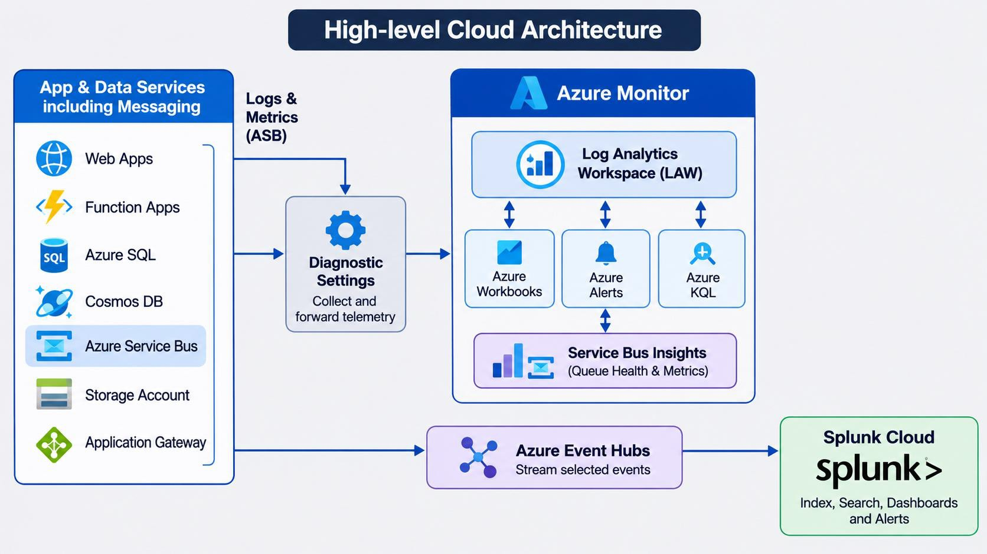

What telemetry should we collect?

Resource | Important telemetry
App Service | HTTP 4xx/5xx, response time, requests, CPU, memory, restarts
Azure Functions | Execution count, failures, duration, exceptions
Application Gateway | Backend health, failed requests, response status, latency
Azure SQL | CPU, DTU/vCore utilization, connections, deadlocks, query performance
Virtual Machines | CPU, memory, disk, network, Windows/Linux events
Storage Account | Availability, latency, transactions, throttling, failures
Key Vault | Access failures, throttling, audit events
Service Bus | Active messages, dead-letter messages, queue depth, processing failures
AKS | Node health, pod restarts, CPU/memory, container logs
API Management | Request count, latency, backend failures, response codes
Monitoring data can be grouped into four main types:
Platform metrics – resource utilization and performance. Resource logs – detailed service-specific events.
Application telemetry – requests, dependencies, exceptions and traces.
Activity and audit logs – configuration changes, administrative actions and security events.

How Azure monitoring works

- Our applications and Azure resources
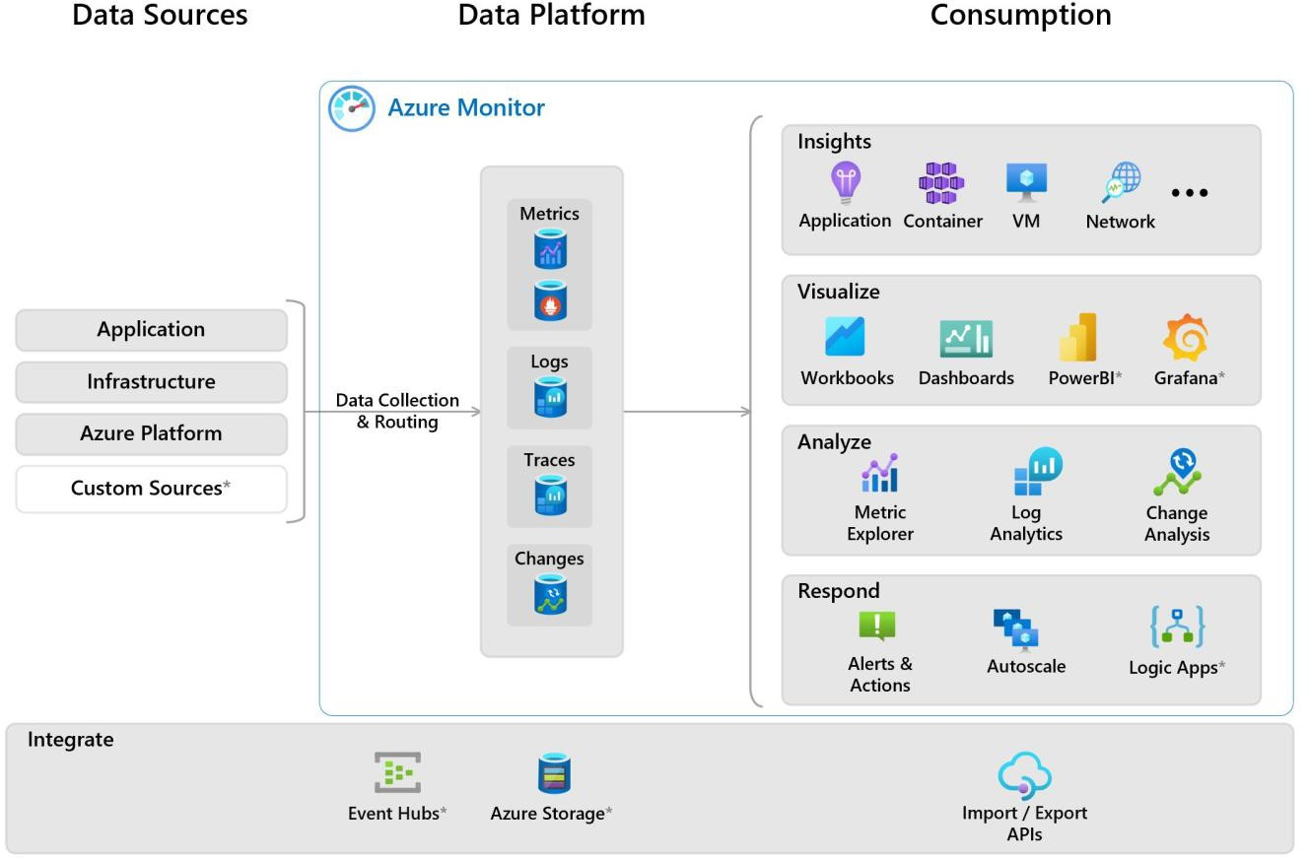
generate telemetry.
- Azure Monitor collects platform metrics and monitoring data.
- Diagnostic Settings route selected resource logs to the required destination.
- Application Insights collects application-
level telemetry.
- Log Analytics Workspace stores supported log data for querying and analysis.
- Azure Monitor Workbooks visualize the
information.
- Alert rules continuously evaluate defined conditions.
- Notifications are sent to the responsible support teams.

What is LAW and why do we need it?
LAW stands for Log Analytics Workspace.
Think of it as a centralized location where we can store, search, analyze and correlate logs from multiple Azure resources. For example, suppose our application uses:
  - One App Service.
  - One Application Gateway.
  - One Azure SQL Database.
  - One Key Vault.
  - One Storage Account.
Instead of checking logs separately on every resource, we can send the required logs to a common workspace and query them
together using Kusto Query Language (KQL).
Benefits:
  - Centralized log collection.
  - Cross-resource troubleshooting.
  - KQL-based searches.
  - Integration with Azure Monitor Alerts.
  - Workbooks and dashboard reporting.
  - Configurable retention and table-level data management.

What is Splunk?
Splunk is a central log analytics and monitoring platform that can collect data from multiple environments, including Azure, AWS, on-premises servers, applications and network devices.
In our scenario, we can send selected Azure logs to Splunk through Azure Event Hubs. For example:
Azure Web App → Azure Diagnostic Settings → Event Hubs → Splunk.
Splunk processes and indexes the data, allowing engineers to search it using SPL (Search Processing Language).
Main features of Splunk
- Centralised monitoring across different platforms.
- Powerful log searching and filtering.
- Custom dashboards and visualisations.
- Scheduled alerts and notifications.
- Application and infrastructure monitoring.
- Correlation of logs from multiple environments.
- Integration with existing operational and security monitoring processes.

LAW vs Splunk – technical comparison

Comparison | Azure LAW | Splunk
Platform | Azure-native | Third-party enterprise platform
Primary purpose | Azure log analytics | Enterprise log analytics
Data collection | Azure-native integrations | Forwarders, APIs, Event Hubs and integrations
Query language | KQL | SPL
Azure integration | Excellent | Requires integration and configuration
Cross-platform monitoring | Possible, but less centralised | Strong
Application tracing | Excellent with Application Insights | Depends on instrumentation and Splunk observability capabilities
Dashboards | Azure Workbooks | Splunk Dashboards
Alerts | Azure Monitor Alerts | Splunk Alerts
Retention | Configurable by table and workspace | Depends on Splunk deployment and contract
Ingestion cost | Azure consumption-based | Contract/licence-based
Operational ownership | Azure platform/team | Splunk platform/team
Native Azure troubleshooting | Excellent | Depends on data collected and integration

LAW – Pros and Cons

Pros | Cons
Native Azure integration | Additional Azure consumption cost
Direct KQL queries | KQL learning curve
Easy Azure alert integration | Separate dashboards from enterprise Splunk
Application Insights integration | Large log ingestion can be expensive
Good resource-level visibility | Cross-platform enterprise visibility may be limited

Splunk – Pros and Cons

Pros | Cons
Existing enterprise platform | Data onboarding is required
Cross-platform monitoring | Additional ingestion may affect licence
Centralised dashboards | Azure-specific investigation may need extra configuration
Powerful search and alerting | Data forwarding infrastructure to maintain
Existing team experience | May duplicate Azure-native monitoring capabilities

Diagnostic Settings: Why are they required?

A common question is: If Azure already collects metrics, why do we need Diagnostic Settings?
The answer is that Azure platform metrics and activity logs are generally available automatically in Azure Monitor, but resource-specific logs aren't automatically stored in a Log Analytics Workspace.
Diagnostic Settings tell Azure:
- Which log categories should be collected?
- Should platform metrics also be exported?
- Where should the data be sent?
- Should it go to Log Analytics, Storage Account, Event Hubs or a supported partner destination?
- Note: We can also configure diagnostic settings through Azure Policy for large environments.

Example: Application Gateway
Without Diagnostic Settings:
  - We can view supported platform metrics.
  - We won't automatically have its resource logs in LAW. With Diagnostic Settings:
  - Select Access Logs.
  - Select Performance Logs.
  - Select Firewall Logs, if applicable.
  - Select Log Analytics Workspace as destination.
  - Save the configuration.
Now the selected logs can be queried centrally.
Microsoft also supports routing diagnostic data to multiple destinations, which is important when considering a hybrid LAW and Splunk approach. Each resource can have up to five diagnostic settings.
Ref: Diagnostic Settings

Can we send the same logs to both LAW and Splunk?

Azure Diagnostic Settings support multiple destinations in the same setting, including a Log Analytics Workspace and an Event Hub.
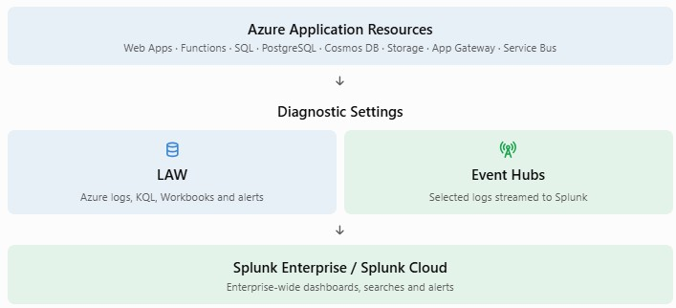

Limitation: Microsoft allows up to five diagnostic settings per resource, with no more than one destination of
each type in an individual setting.

What if we stream all diagnostic logs to LAW?
Technically, we can collect a large portion of the available diagnostic logs into LAW. However, I would not recommend enabling every available category across every resource without analysing the data first.
Why?
- More logs mean more ingestion.
- More ingestion means higher Azure monitoring charges.
- Some logs are useful for daily operations, while others are only useful for auditing or historical investigations.
- Duplicate application logs may be collected through both Application Insights and other logging mechanisms.
- Some platform metrics are already collected automatically and do not need to be exported into LAW.
Microsoft specifically recommends selecting required categories and using filtering/transformation options where supported to control ingestion costs.

How monitoring helps in troubleshooting and tracing
Consider a real production issue.
Scenario: Users report that the application is taking 10–15 seconds to load.

How we investigates

Step | What the engineer checks | Monitoring tool
1 | Is the application available? | Azure Monitor
2 | Is the response time increasing? | Application Insights
3 | Are there HTTP 500 errors? | LAW / Splunk
4 | Which component is taking more time? | Application Insights distributed traces
5 | Is the database responding slowly? | SQL metrics and logs
6 | Are messages getting stuck? | Service Bus metrics and logs
7 | Did any deployment or configuration change happen? | Azure Activity Log
8 | What is the root cause? | Correlated logs, metrics and traces

For example:
- Application Insights identifies that the Web App request is taking 12 seconds.
- Distributed tracing shows that 9 seconds are spent waiting for Azure SQL.
- SQL monitoring identifies slow
queries or connection issues.
- The engineering team investigates the query or connection pool.
- After the fix, the response time returns to normal.
- Without proper monitoring, engineers may spend hours checking different resources manually.
- With proper monitoring, they can narrow down the problem much faster.

Cost consideration
Illustrative daily log ingestion scenario
50 GB/day Example only 1,500 GB
30-day ingestion volume
18,250 GB
365-day ingestion volume
If we send the same 50 GB/day to both platforms:
LAW: Charges for applicable ingestion and retention.
Splunk: Consumes the applicable Splunk ingestion or workload entitlement. Event Hubs: May have additional capacity and transaction charges.
Data transfer: May have applicable network charges.

Should we use LAW, Splunk or both?
Recommend to Use Hybrid – Both LAW and Splunk
Use Azure-native monitoring for application troubleshooting and resource health. Send selected operational and enterprise-relevant logs to Splunk.
Advantages:
Native Azure troubleshooting. Existing Splunk investment is utilised.
Enterprise-wide monitoring remains centralised. Critical alerts can be configured in Azure.
Splunk can correlate Azure events with non-Azure environments.
Disadvantages:
Additional ingestion and retention cost if the same data is stored in both systems. More than one dashboard to maintain.
Requires clear ownership and data collection standards.

Recommended Approach

Monitoring requirement | Recommended platform
Application performance monitoring | Application Insights
Distributed tracing | Application Insights
Azure resource metrics | Azure Monitor
Native Azure resource health | Azure Monitor
Application-specific troubleshooting | LAW
Azure operational dashboards | Azure Workbooks
Azure critical alerts | Azure Monitor Alerts
Enterprise-wide dashboards | Splunk
Cross-platform log correlation | Splunk
Centralised enterprise reporting | Splunk
Selected Azure security and audit logs | Splunk, according to enterprise requirements

Practical Monitoring Model

Frequency | Monitoring activity | Expected outcome
Daily | Check application availability | Identify outages
Daily | Review HTTP 4xx/5xx errors | Identify application failures
Daily | Check response time and latency | Identify performance issues
Daily | Review database health | Identify database bottlenecks
Daily | Check Function App failures | Identify processing failures
Daily | Check Service Bus dead-letter messages | Identify failed business  transactions
Daily | Review Event Hubs throttling | Identify streaming problems
Daily | Review critical and warning alerts | Identify incidents requiring action
Weekly | Review recurring errors | Identify long-term issues
Weekly | Review resource utilisation | Identify capacity problems
Weekly | Review ingestion volume | Control monitoring costs
Monthly | Review retention and alert thresholds | Optimise costs and operations

Questions

- Is your existing Splunk deployment Splunk Cloud or Splunk Enterprise?
- Is your licence based on daily ingestion volume or workload?
- Do we currently send any Azure logs to Splunk?
- Are we monitoring only production resources or development, UAT and production?
- What is the required retention period: 30, 90, 180 or 365 days?
- Forwarders or Internal tool
- Splunk add-on or other method

References

- Azure Monitor cost and usage
- Azure Monitor pricing and log ingestion plans
- Azure Monitor Logs cost calculations
- Azure Diagnostic Settings
- Streaming Azure Monitor data to Event Hubs and external
partners
- Splunk Azure Event Hubs integration
- Azure Monitor data sources and collection methods

Which dashboards should we create for daily monitoring?
Dashboard 1 – Application Health Overview

Dashboard component | What it shows
Application availability | Available / unavailable
Total requests | Incoming traffic
Failed requests | HTTP 4xx and 5xx trends
Average response time | Application performance
P95 response time | Slow user requests
Exception count | Application errors
Dependency failures | SQL, API and downstream failures

Dashboard 2 – Infrastructure Health
.

- Web App CPU and memory.
- Function execution count and failures.
- SQL CPU, storage and connections.
- PostgreSQL connections and performance.
- Cosmos DB RU consumption and throttling.
- Storage availability and capacity.
- Application Gateway backend health.

Dashboard 3 – Integration and Messaging Health

- Event Hub incoming messages.
- Event Hub throttled requests.
- Service Bus active messages.
- Dead-letter message count.
- Message processing failures.
- Oldest message age.
- Function processing failures.

Dashboard 4 – Operations and Alert Summary

  - Critical alerts.
  - Warning alerts.
  - Resolved alerts.
  - Top failing applications.
  - Top resources generating errors.
  - Recent production changes.
  - Data ingestion volume.
  - Monitoring pipeline health.

Sample Alerts required

Alert | Condition | Suggested severity
Web App availability | HTTP 5xx error rate above 5% for 5 minutes | Critical
Web App performance | P95 response time above 3 seconds for 10 minutes | Warning
Function App failures | Failure rate above 10% | Critical
Azure SQL | CPU above 85% for 10 minutes | Warning
PostgreSQL | Connections approaching configured limit | Warning
Cosmos DB | Sustained 429 throttling | Warning
Application Gateway | Unhealthy backend instances | Critical
WAF | Sudden increase in blocked requests | Warning
Event Hubs | Incoming requests throttled | Warning
Service Bus | Dead-letter messages above agreed threshold | Critical
Storage Account | Availability below agreed SLA threshold | Critical

Sample KQL queries
- Application exceptions
Kusto
AppExceptions | where TimeGenerated > ago(24h) | summarize ExceptionCount = count() by bin(TimeGenerated, 1h), AppRoleName | render timechart
- Failed application requests
Kusto
AppRequests | where TimeGenerated > ago(24h) | where Success == false | summarize FailedRequests = count() by bin(TimeGenerated, 1h), AppRoleName | render timechart
3. Application response time
Kusto
AppRequests | where TimeGenerated > ago(24h) | summarize AverageDuration = avg(DurationMs), P95Duration = percentile(DurationMs, 95) by bin(TimeGenerated, 1h) | render timechart
4. Azure resource errors
Kusto
AzureDiagnostics | where TimeGenerated > ago(24h) | summarize TotalErrors = count() by ResourceProvider, Category | order by TotalErrors desc

Sample SPL queries
1. Application errors
Spl
index=azure sourcetype=azure:monitor:resource | search Level=Error OR level=Error | stats count by Resource, Category | sort – count
2. Failed requests
Spl
index=azure sourcetype=* | search status=500 OR status=502 OR status=503 | timechart span=1h count
3. Resource-level error monitoring
Spl
index=azure | stats count by host, sourcetype | sort - count

